**GUI - JPanels and BoxLayout**

We will now improve on our last program that was a simple calculator. This time the layout of the components and the purpose will change. Use a combination of BoxLayout and JPanels to make the layout.

* Label A will now contain the operator that is being used. It sits between the two textboxes. Notice how the operator changes when a different buttons is used.
* Label B will contain all the output messages (notice how the color changes when a different button is used)

Hints:

* You will need to set the preferred sizes or starting size of the text fields and labels to make them look nice.
* Use the pack() method with the frame instead of setting a size
* Do not directly put a Layout onto the JFrame. Instead make a master JPanel that will have a layout that will hold all the other JPanels and components.

Example:

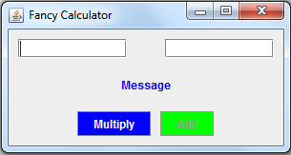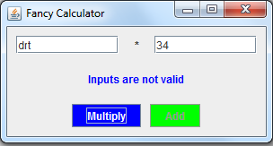

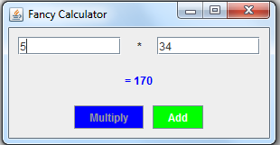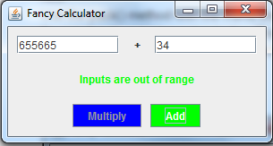

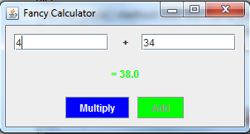

|  |
| --- |
| import javax.swing.event.*;  import javax.swing.*;  import java.awt.*;  import java.awt.event.*;  public class GUI implements ActionListener  {  JFrame f;  Container container;  JButton btnA, btnB;  JTextField txtA, txtB;  JLabel lblA, lblB;  boolean valid;    public static int numA;  public static double numB;    JPanel txtPanel, btnPanel, msgPanel, mainPanel;    public GUI()  {  f = new JFrame("Fancy Calculator");    mainPanel = new JPanel();  mainPanel.setLayout(new BoxLayout(mainPanel, BoxLayout.Y_AXIS));    txtPanel = new JPanel();  msgPanel = new JPanel();  btnPanel = new JPanel();    btnA = new JButton("Multiply");  btnB = new JButton("Add");  txtA = new JTextField(12);  txtB = new JTextField(12);  lblA = new JLabel(" ", JLabel.CENTER);  lblB = new JLabel("Message", JLabel.CENTER);    btnA.setBackground(Color.BLUE);  btnB.setBackground(Color.GREEN);  lblB.setForeground(Color.BLUE);    btnA.addActionListener(this);  btnB.addActionListener(this);  btnB.setEnabled(false);    //Text Panel  txtPanel.add(txtA);  txtPanel.add(lblA);  txtPanel.add(txtB);    //Message Panel  msgPanel.add(lblB);    //Button Panel  btnPanel.add(btnA);  btnPanel.add(btnB);    //Add the Components to the mainPanel  mainPanel.add(txtPanel);  mainPanel.add(msgPanel);  mainPanel.add(btnPanel);    f.add(mainPanel);    f.pack();  f.setResizable(false);  f.setLocationRelativeTo(null);  f.setDefaultCloseOperation(JFrame.EXIT_ON_CLOSE);    f.setVisible(true);  }    /**  * Method Name : checkText  * @param JTextField txtA - stores the whole number  * @param JTextField txtB - stores the decimal number from -500 to 500  * @param JLabel label - message Label output  * @param Color color - Stores the color of the message label  * @return boolean - whether the inputs are valid or not  * **/  public static boolean checkInput(JTextField txtA, JTextField txtB, JLabel label, Color color)  {  label.setForeground(color);    try  {  numA = Integer.parseInt(txtA.getText());    //Display an error if the JTextField- A has integer less than 0  if(numA < 0)  {  label.setText("Whole number required");  return false;  }    numB = Double.parseDouble(txtB.getText());    //Display an error if the JTextField- B is not in range of -500 to 500  if(!(numB >= -500 && numB <= 500)){  label.setText("Inputs are out of range");  return false;  }    return true;    //label.setText("<html> Error 1 <br/> Error 2 </html>");  }    //Invalid Inputs given  catch(NumberFormatException e)  {  label.setText("Inputs are not valid");    }//end try/catch    return false;    }//end checkInput(JTextField, JTextField, JLabel, JLabel)    public void actionPerformed(ActionEvent e)  {  //If button "multiply" is to be executed  if(e.getSource() == btnA)  {  lblA.setText(" * ");  valid = checkInput(txtA, txtB, lblB, Color.BLUE);    //If both the inputs are valid,, then do the multiplication  if(valid)  {  btnA.setEnabled(false);  btnB.setEnabled(true);  lblB.setText(" = " + (numA * numB));  }  }    //If button "add" is to be executed  else  {  lblA.setText(" + ");  valid = checkInput(txtA, txtB, lblB, Color.GREEN);    //If both the inputs are valid, then do the addition  if(valid)  {  btnA.setEnabled(true);  btnB.setEnabled(false);  lblB.setText(" = " + (numA + numB));  }  }  }    //Main  public static void main(String[] args)  {  new GUI();  }  } |
| Screenshots (your version): |
|  |
|  |